Social & Emotional Learning Activities

Created by: PIRS Ms. Torres, Ms. Berger, Ms. Strelec, & Ms. Smith

1. 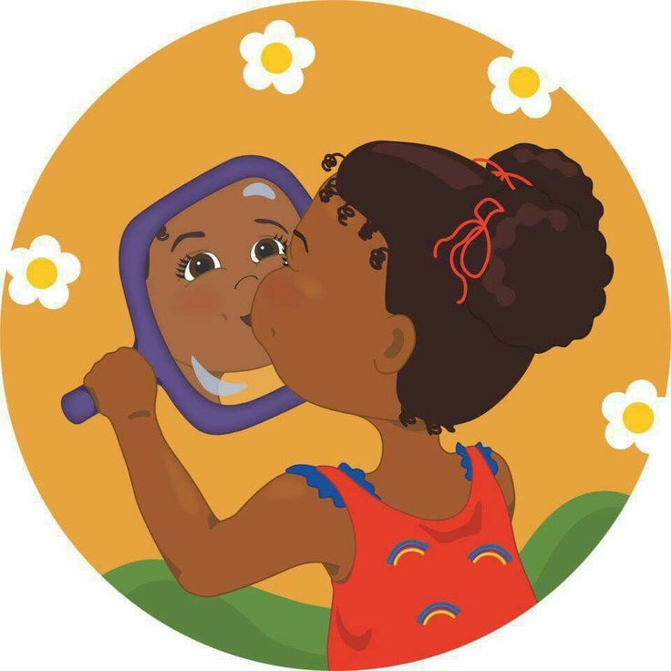**Exploring Emotions**

During bathroom routines, have your child look in the mirror and practice making mad/sad/happy faces together. You can make a happy face and say (for example), “I have a happy face because I’m happy to be here with you!” Ask your child, “What makes you have a happy face?” You can do the same with other emotions such as angry/mad face, sad face, silly face, etc.

Here is a video with the Storybots about emotions. It has lots of fun music to dance to. It is 11 minutes long: <https://youtu.be/akTRWJZMks0>

1. **Creating & Using Routines**

Children succeed in a well-ordered and predictable environment, where daily routines such as arrivals and departures, mealtimes, nap times and toileting are dealt with consistently by all caregivers. Daily routines provide opportunities for children to learn more about themselves, the world and other people. Daily routines also offer children a sense of stability, and a feeling of warmth and caring from their teachers. The challenge is to develop appropriate daily routines for children which offer them a sense of consistency and security, yet remain flexible and responsive to the individual needs of each child.

* 1. **Daily Schedule**

In order to establish daily routines, most preschool virtual classrooms follow a basic daily schedule. Among other things, a schedule can help to ensure the consistency that young children need and also help teachers encourage all areas of development by planning a wide range of activities. It's helpful to think of a daily schedule as a guide which is responsive to children and teachers. In creating schedules, it is also important to provide a healthy balance for children, between group times and more solitary moments, quiet and noisy activities, indoor and outdoor play.

* 1. **Transitions**   
     Transition times are important because they can make the day seem smooth and well-organized, or rushed and unpleasant. Allowing enough time so children make the transition gradually is the best way to avoid stressful situations. In addition to allowing a realistic amount of time for transitions to take place, it always helps to warn once in advance before a change in activities. This gives the children a chance to finish what they are doing and their cooperation is more likely. It might also help move the process along if we comment favorably about the next activity and avoid situations where all the children are expected to do the same thing at the same time.

**SAMPLE OF A ROUTINE AT HOME**

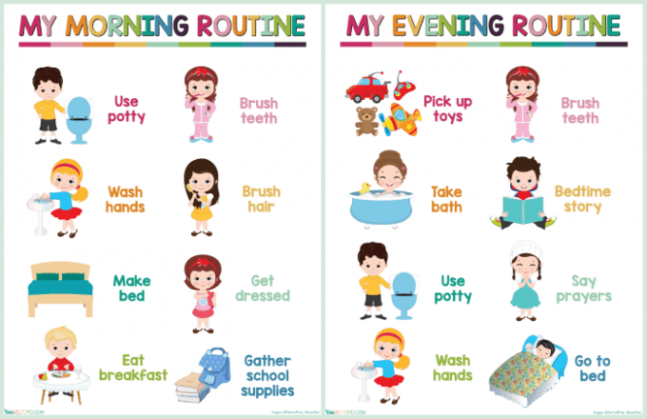

**For your child’s school day, follow the teacher’s daily schedule.

|  |  |
| --- | --- |
| **Time** | **Activity** |
| 8:30 am to 9:00 am | Breakfast time preparation/set up for the start of the school day (be sure that all technology is charged up and that materials and supplies for the day are ready in advance) |
| 9:00 am to 10:00 am | Greeting Time – live instruction  Message Time – live instruction  Read Aloud – live instruction (story, discussion, questions)  (children will have a 5 min brain break) |
| 10:00 am to 11:00 am | Outside Time/Work Time (flexibility):  Children can work independently on assigned tasks  Children can engage in hands on activities and creative arts (i.e. painting, finger painting, drawing, playdough, collaging)  Children can develop their large muscles by going outside or to the park to run, jump, play ball, ride a tricycle, etc.  Children can engage in mindfulness strategies, yoga, and stress release activities |
| 11:00 am to 12:00 pm | Large Group Time: music and movement, songs, nursery rhymes, dance, etc.  Small Group Time (teacher and para will break up into two small instructional groups):  Monday – English Language Arts (ELA)  Tuesday – Math  Thursday – Science  Friday – Social Emotional Learning (SEL)  (children will have a 5 min brain break) |
| 12:00 pm to 1:30 pm | Lunch/Nap Time for Children |
| 1:30 pm to 3:00 pm | Outside Time/Work Time (flexibility):  Children can work independently on assigned tasks  Children can engage in hands on activities and creative arts (i.e. painting, finger painting, drawing, playdough, collaging)  Children can develop their large muscles by going outside or to the park to run, jump, play ball, ride a tricycle, etc.  Children can engage in mindfulness strategies, yoga, and stress  release activities  Teachers are available to meet and to provide extra support to children as necessary |

1. **Paper Plate Emotions**

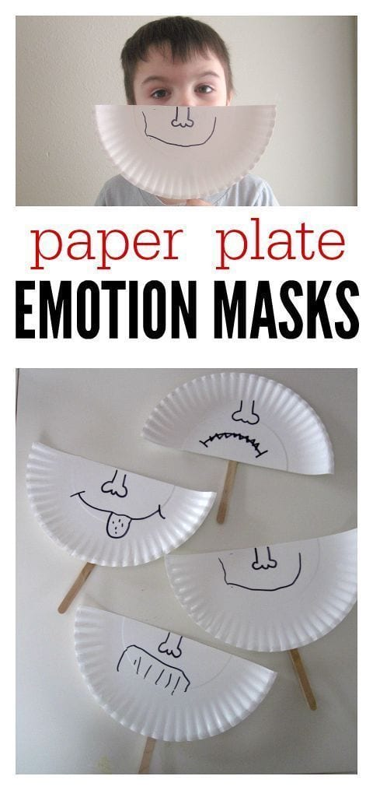

This activity can also be done using simple paper and marker if paper plates are not available. Straws can also be substituted for popsicle sticks or whatever else you may have around your home.

**Activity**: Cut the paper plate or paper in half and have your child (with your help if necessary) draw an emotion face to the best of your ability. For younger students (3 year olds) keep emotions simple such as happy and sad. For older students (4+) emotions can be more complex such as angry, happy, excited, disappointed, excited, or worried.

You or others in your household can play a simple game with your child by having the child identify each emotion in a fun way (Example: hiding it behind your back then whipping it to the front while they call out the emotion names). Use this opportunity to discuss emotions with your child. You can lead off the conversation by describing how emotions affect you. “I feel sad when it rains and we can’t go to the park” “I feel happy when you eat all of your vegetables”. You can then ask your child to do the same by telling you or showing you by pointing if necessary.

1. Social & Emotional Learning Video

This is a short video explain SEL and why it matters. Teachers can view it to give themselves a better understanding for SEL as well as s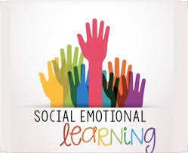hare it with their families.

<https://youtu.be/ikehX9o1JbI>